1. In Economy class Baggage is displaying 0PC for Routing LHR-JFK-EWR-LHR and for other class its working fine[Can't find the issue.]

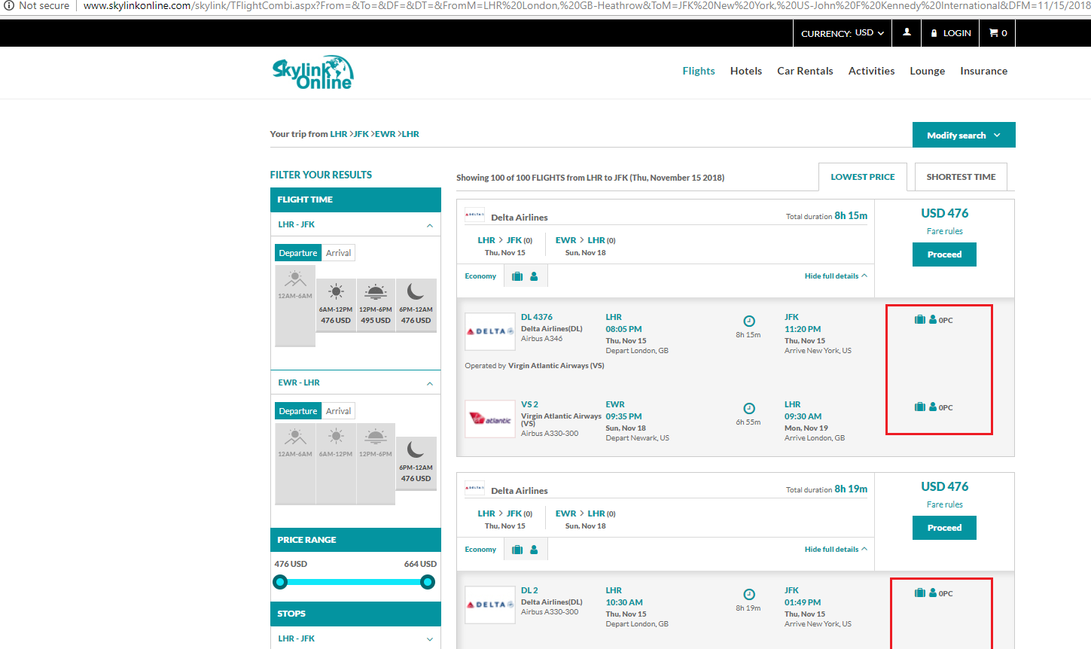

1. No Penalties updated for EWR-LHR[Supplier dependency]

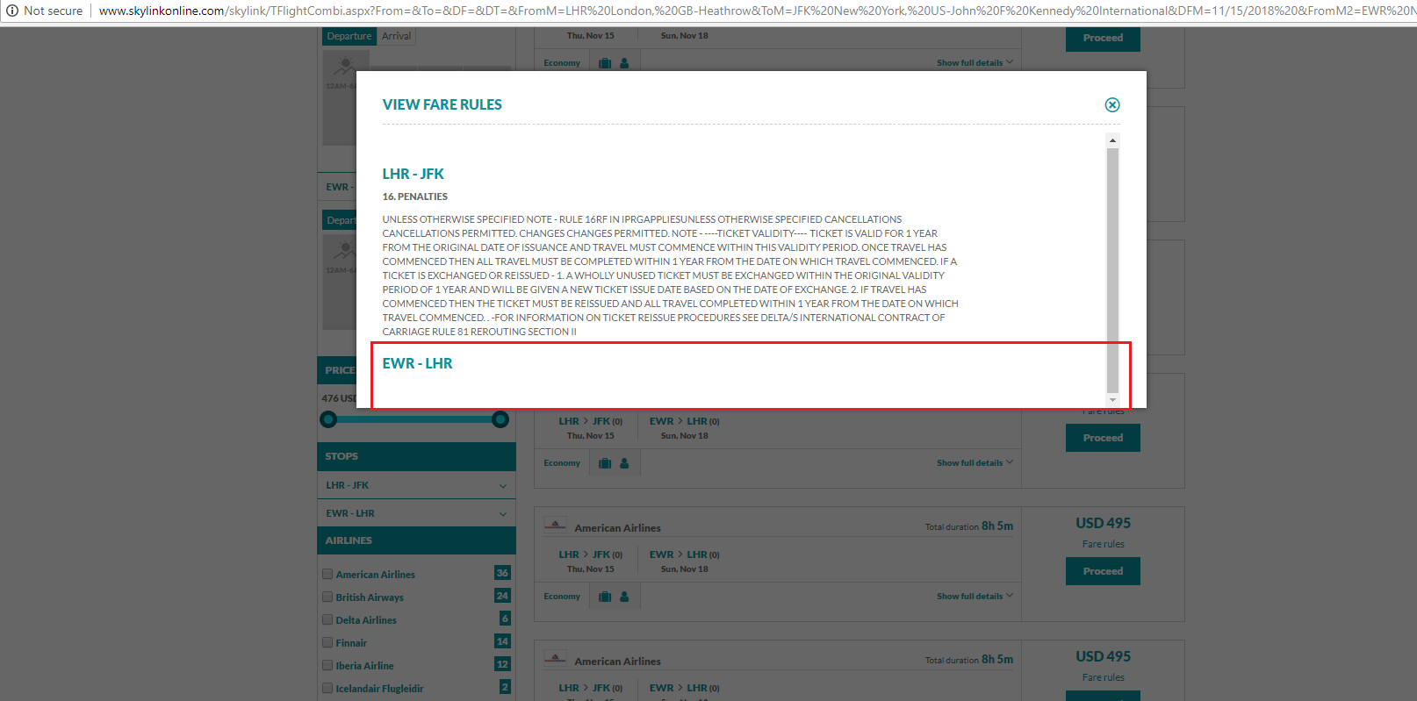

1. When we are clicking on Lowest price or shortest time, it is taking time to show results[working fine]

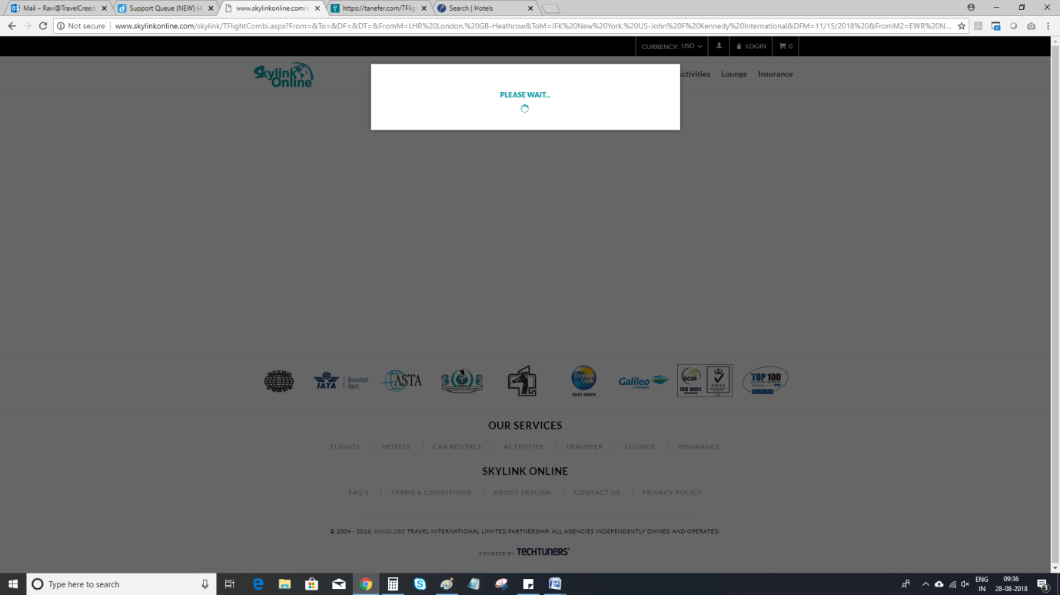

1. When Clicking on Next Step review in Passenger page, Page redirected to the Home Screen[working fine]

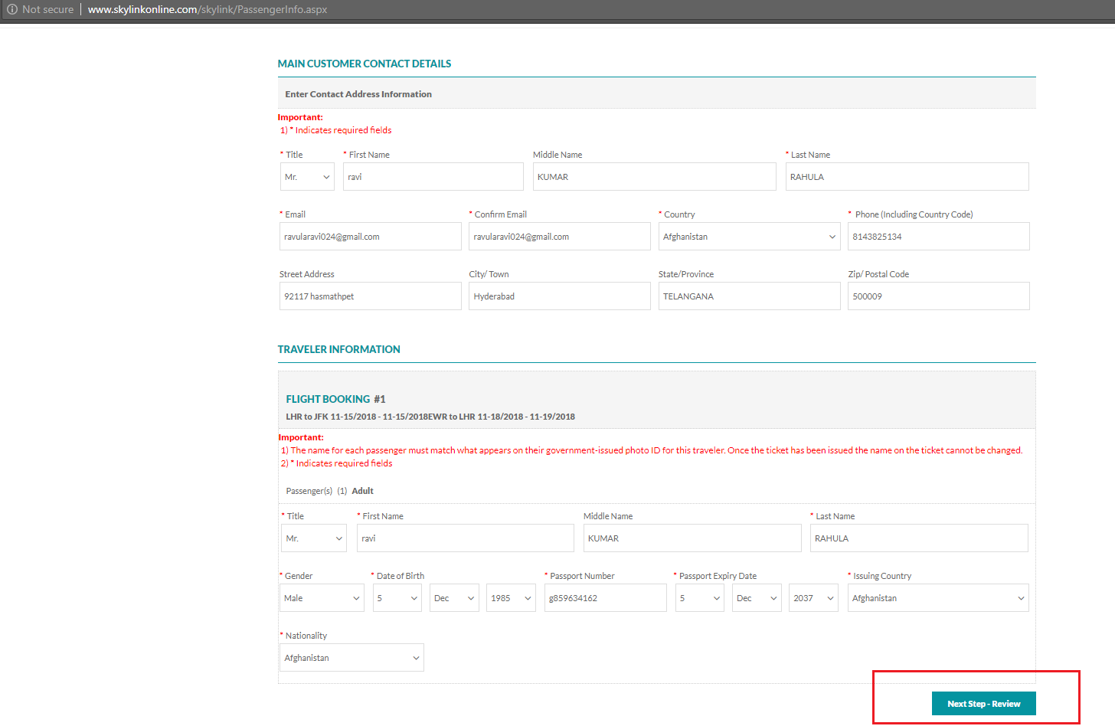

1. In Map Location/View Map there is no direction of Map, its background shows blank[supplier Dependency]

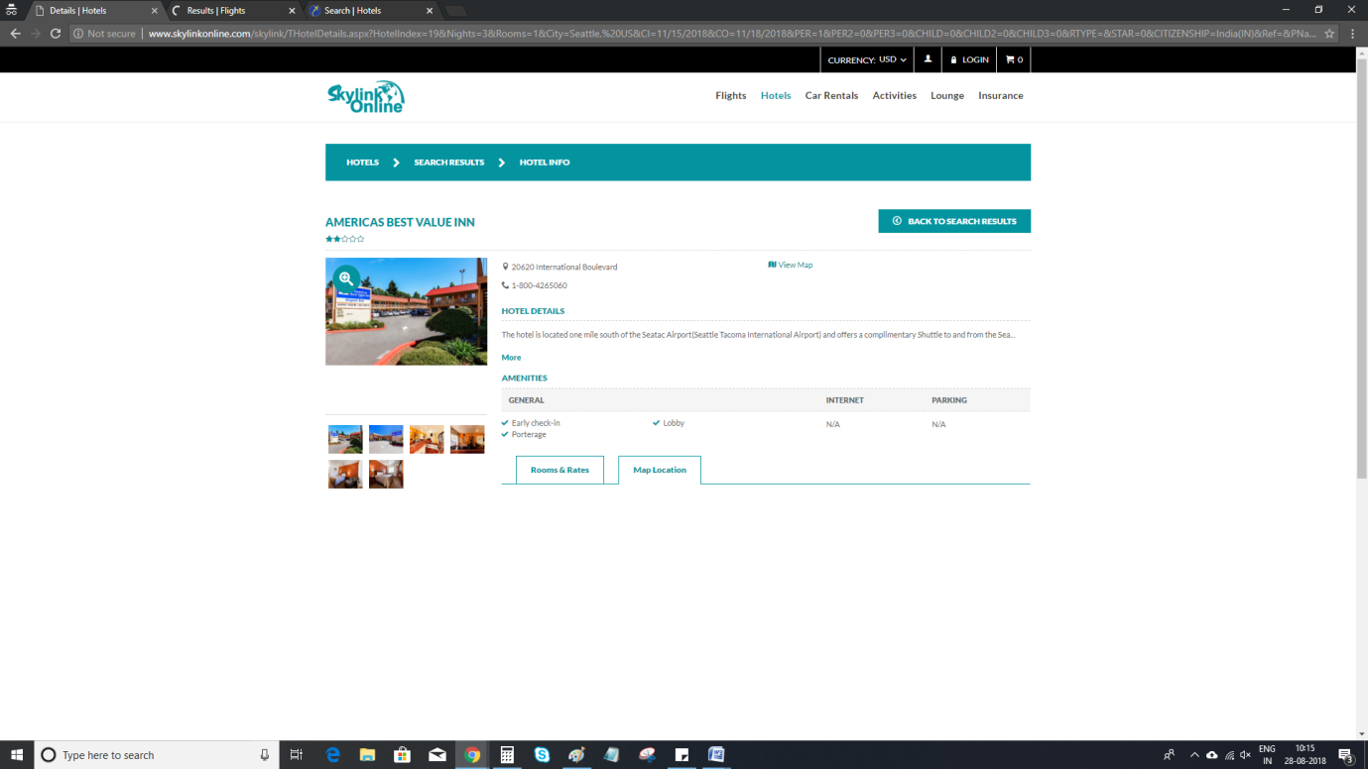

1. Activities: Kindly remove the slider option in review page, and there are twice fare breakup Grid[working fine]
2. No Terms & Conditions[working fine]

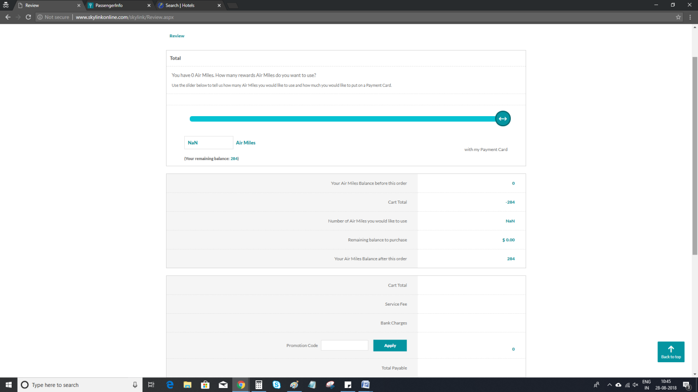

1. In Economy class Baggage is displaying 0PC for Routing LHR-JFK-EWR-LHR and for other class its working fine[Can't find the issue.] Check routing for Multi city LHR-JFK 15NOV18 and EWR-LHR 18NOV18

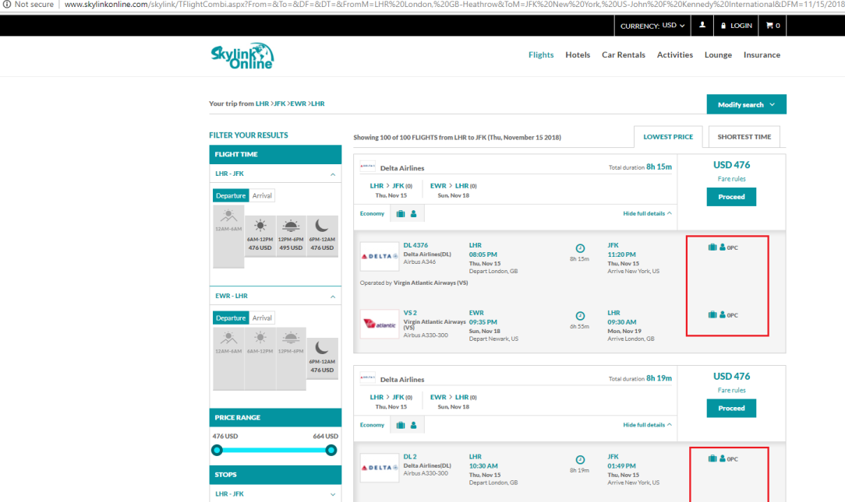

1. No Penalties updated for EWR-LHR[Supplier dependency] [Ravi] Kindly raise this issue with supplier



1. When we are clicking on Lowest price or shortest time, it is taking time to show results[working fine] [Ravi] It take 10-13 seconds to load the results

